3GPP TSG-RAN WG4 Meeting #119 R4-2605757
Dalian, China, 18th – 22th May 2026

Source: Huawei, HiSilicon
Title: On 6GR Sensing use cases and sensing modes
Agenda Item: 8.10.2
Document for: Approval

Introduction
For the RAN study on 6G scenarios and requirements, the sensing related use cases in the TR [1] are as follows:

5.4.4 Sensing
Editor note: More sensing use cases can be included depending on further discussion.
The 6GR and 6G RAN architecture shall at least support use cases of
- detection and/or tracking of passive objects, at least including UAVs, human, vehicles and AGVs
- communication assistance.
For the RAN4 study on 6G Radio, the sensing related objectives agreed for the study [2] are as follows:
(9) Sensing – Studies to be based on use cases and associated requirements, as defined in [TR38.914]
- PHY functions and procedures for sensing technology (e.g., waveform. reference signals, measurement feedback, etc…) [RAN1, RAN4]
- Evaluate sensing performance and if necessary, extend channel modelling, for the selected use cases [RAN1]
- Aspects of integration with communication services [RAN1]
- higher layer procedures and protocol aspects [RAN2]
- RAN4 aspects of sensing including RF, coexistence, and testability in coordination with other WGs [RAN4]
Note: RAN1 identify detailed requirements, if triggered by TSG RAN
In RAN4#118bis, the agreement [3] on the use cases and sensing modes for 6G sensing study is excerpted as below.
  - Agreement for the scenarios (sensing modes and sensing target) for 6G sensing coexistence study from RAN4 work management perspective:
    - UAV (passive object), TRP monostatic
      - FFS on Multiple TRP monostatic.
    - Vehicle (passive object), TRP-UE bistatic
    - [TBD] (passive object), UE-TRP bistatic
    - UAV (passive object), TRP-TRP bistatic
  - RAN4 doesn’t preclude any 6G scenarios as agreed by RAN-P and RAN1;
This contribution provides our further considerations on use cases and sensing modes for 6G sensing.

Discussion
In last RAN4#118bis meeting, it was agreed that the sensing scenario is identified by the combination of sensing target and sensing mode. Generally, there are six basic sensing modes in addition to multi-static sensing identified for 6G sensing, as shown in Figure 1. From RAN4 work management perspective, two sensing targets, i.e. UAV and vehicle, and four sensing modes, i.e. aNB monostatic, aNB-aNB bi-static, aNB-UE bi-static, UE-aNB bi-static, have been agreed for 6G sensing coexistence study.
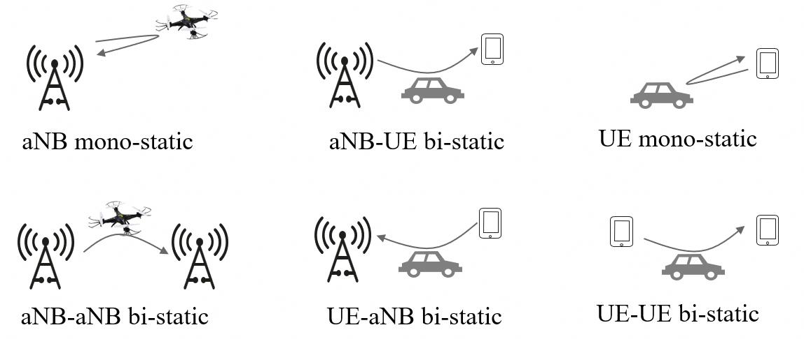
Figure 1: Basic sensing modes considered in 6G sensing.

UAV Sensing Scenario
For the UAV sensing scenario, Rel-20 5GA carried out substantial evaluations of both single and multiple aNB mono-static sensing, and completed the study from RAN1 perspective.
As per the evaluation results from most companies in [4], utilizing measurements from multiple TRPs, i.e. multiple aNB mono-static sensing, achieves better performance than that from single TRP, i.e. aNB mono-static sensing. It is noted that measurement fusion is conducted at core networks. From the RAN perspective, signal transceiving and processing procedures for both modes are identical. Thus, for the study of 6G UAV sensing with multiple aNB mono-static, there are no impact for RAN is observed, in addition to that for aNB mono-static.
Observation 1: For the UAV sensing scenario, multiple aNB mono-static sensing achieves better performance than aNB mono-static sensing.
Observation2: For multiple aNB mono-static sensing, measurements from multiple TRPs are fused at core network, while the signal transceiving and processing procedures are identical to aNB mono-static sensing from RAN perspective.
Proposal 1: For the study of 6G UAV sensing with multiple TRP monostatic, no impact for RAN is observed, in addition to that for TRP monostatic.
As per the evaluation results from most companies in [4], aNB mono-static sensing could achieve the performance objectives for UAV sensing scenario, without incorporating aNB-aNB bi-static sensing. Furthermore, regarding the RAN study of 6G sensing scenarios and requirements, no additional performance requirements have been identified for UAV sensing scenario [1]. Therefore, the study of aNB mono-static sensing should be prioritized for UAV sensing.
Observation 3: Multiple aNB mono-static sensing could meet the performance objectives for UAV sensing scenario in 5GA sensing study, while no additional performance objectives are identified for UAV sensing in the RAN study of 6G sensing.
Proposal 2: aNB mono-static sensing should be prioritized for the UAV sensing scenario.

Vehicle Sensing Scenario
From 6GR air interface perspective, the wireless time/frequency/spatial resource is expected to be efficiently used for both sensing and communication performance irrespective of the sensing modes to be invoked.
For vehicle sensing scenario, there are widely distributed UEs near the targets, which introduces lower propagation loss and more measurements with different UEs. Therefore, compared with aNB mono-static sensing, aNB-UE/UE-aNB bi-static sensing could result in better sensing accuracy. Furthermore, to facilitate the multiplexing of uplink and downlink signals for both sensing and communication as much as possible, both aNB-UE and UE-aNB bi-static sensing should be studied.
In last RAN4#118bis meeting, UE-aNB bi-static mode has been agreed for the scenarios for 6G sensing study, while the passive target is left to be determined. Concerning that the target sensing scenarios for both aNB-UE and UE-aNB bi-static sensing modes are identical, it is proposed that aNB-UE and UE-aNB bi-static sensing should be prioritized for the study of 6G vehicle sensing.
Proposal 3: For the study of 6G vehicle sensing, aNB-UE and UE-aNB bi-static sensing should be prioritized.

Others
The use cases of sensing vehicle and AGV are common in terms of the mobility characteristic and are the two typical sensing cases as well for outdoor and indoor, respectively. Given the limited TUs for RAN4 study and the fact that vehicle sensing scenario has been agreed for study, it is proposed to focus on the study of the agreed vehicle sensing scenario. As for human sensing use case, it inevitably may raise the question of privacy in our view.
With respect to UE mono-static and UE-UE bi-static sensing modes, their applicable sensing scenarios and feasibility remain unclear in our view. It is proposed that the two modes are left for discussion later for RAN4 study until adequate progress is achieved in other working groups.

Conclusion
This contribution provides our further considerations on use cases and sensing modes for 6G sensing.
Observation 1: For the UAV sensing scenario, multiple aNB mono-static sensing achieves better performance than aNB mono-static sensing.
Observation2: For multiple aNB mono-static sensing, measurements from multiple TRPs are fused at core network, while the signal transceiving and processing procedures are identical to aNB mono-static sensing from RAN perspective.
Proposal 1: For the study of 6G UAV sensing with multiple TRP monostatic, no impact for RAN is observed, in addition to that for TRP monostatic.
Observation 3: Multiple aNB mono-static sensing could meet the performance objectives for UAV sensing scenario in 5GA sensing study, while no additional performance objectives are identified for UAV sensing in the RAN study of 6G sensing.
Proposal 2: aNB mono-static sensing should be prioritized for the UAV sensing scenario.
Proposal 3: For the study of 6G vehicle sensing, aNB-UE and UE-aNB bi-static sensing should be prioritized.

References
- RP-260073, RAN TR 38.914, Study on 6G scenarios and requirements (Release 20), V0.4.0 (2026-03).
- RP-251881, New SID: Study on 6G Radio, NTT DOCOMO (Moderator), RAN#108, Prague, Czech Republic, June 9-13, 2025.
- R4-2605009, Way Forward for [118bis][362] 6G_Sensing, ZTE, RAN4#118bis, St. Julian’s, Malta, April 13-17, 2026.
- TR38.765, Study on Integrated Sensing and Communication (ISAC) for NR, V1.0.0 (2026-02).

